**//Trying to predict data with RDD in SCALA facing two types of error**

import org.apache.spark.ml.evaluation.RegressionEvaluator

import org.apache.spark.ml.recommendation.ALS

import org.apache.spark.mllib.recommendation.Rating

case class Rating(userId: Int, movieId: Int, rating: Float, timestamp: Long)

def parseRating(str: String): Rating = { val fields = str.split(",") assert(fields.size == 4) Rating(fields(0).toInt, fields(1).toInt, fields(2).toFloat, fields(3).toLong) }

**//Created RDD through SparkContext**

val ratrawdata = sc.textFile("/user/Test/ratings.csv")

val header = ratrawdata.first()

val ratrawfildata = ratrawdata.filter(line => line != header)

val ratingsdata = ratrawfildata.map(parseRating).toDF()

val Array(training, test) = ratingsdata.randomSplit(Array(0.8, 0.2))

//Build the recommendation model using ALS on the training data

*val als = new ALS().setMaxIter(5).setRegParam(0.01).setUserCol("userId").setItemCol("movieId").setRatingCol("rating")*

**Error no 1:: val model = als.fit(training)**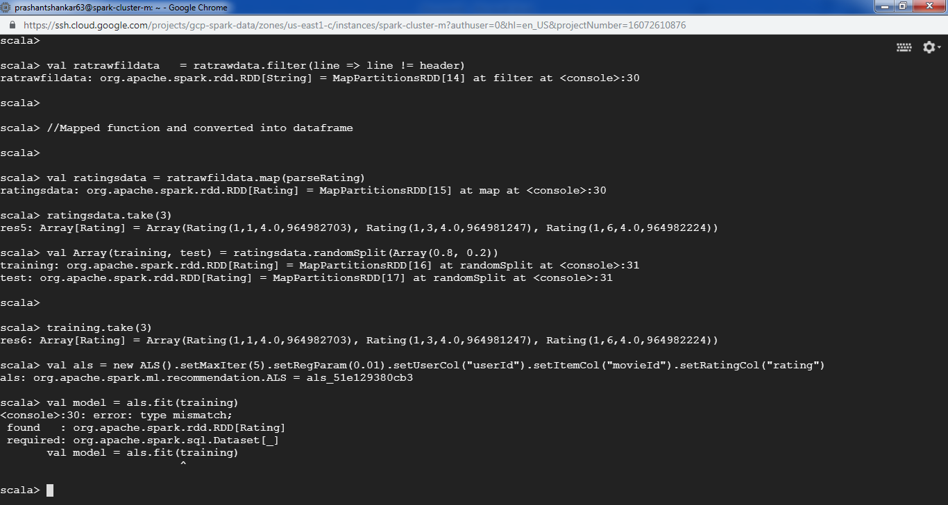

**Error 2nd val ratingsdata = ratrawdata.map(parseRating)**

